Status on 20 January 2020 – Double-click on the relevant cover page to open the corresponding pdf file – You may also search for words or NSS number in the title
The thematic structuring of NSS documents is based on the NSS Roadmap developed by the Nuclear Security Guidance Committee (NSGC)

Nuclear Security Fundamentals NSS 20 Documents supporting the NSS publications
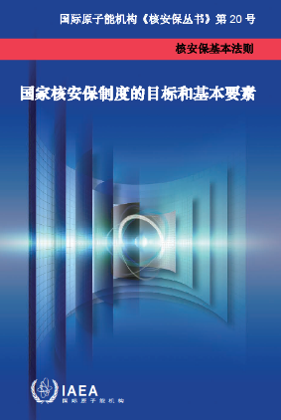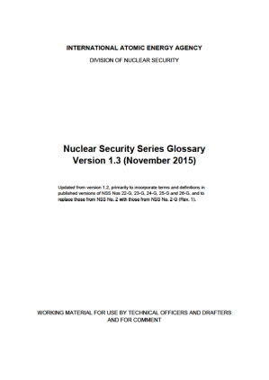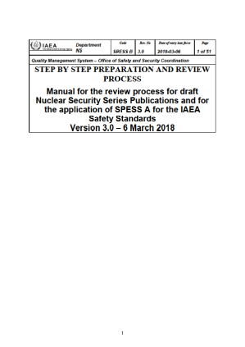
NSS 20: Objective and Essential Elements of a State’s Nuclear Security Regime Nuclear Security Series Glossary SPESS B

Cross-cutting Guidance
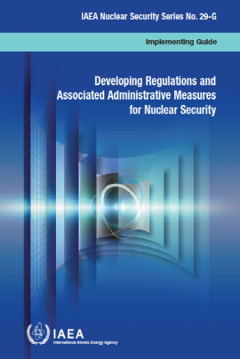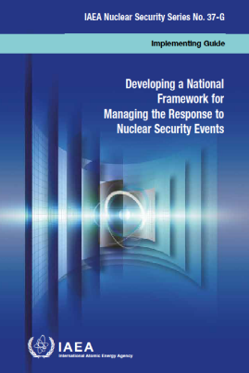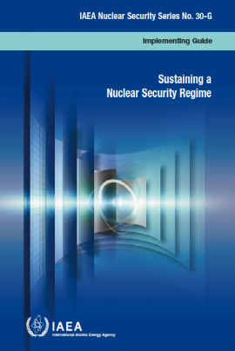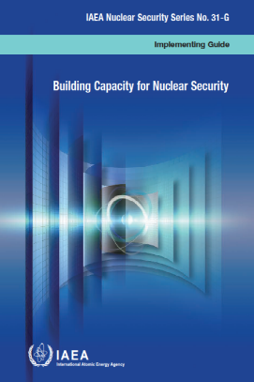
NSS 29-G: Developing Regulations and NSS 37-G: Developing a National Framework NSS 30-G: Sustaining NSS 31-G: Building Capacity
Associated Administrative Measures for Managing the Response a Nuclear Security Regime for Nuclear Security
for Nuclear Security to Nuclear Security Events
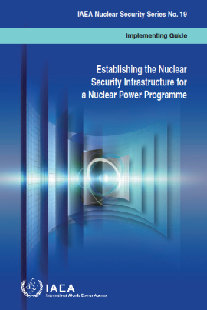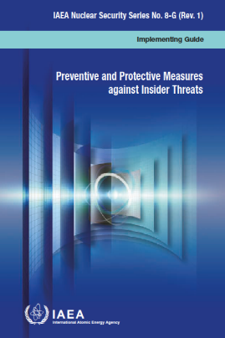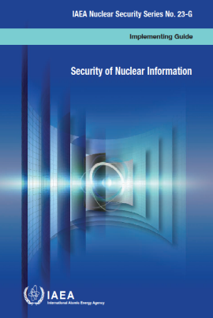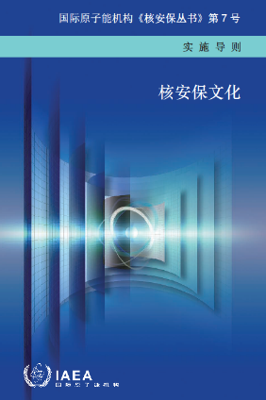
NSS 19: Establishing the Nuclear Security NSS 8-G (Rev. 1): Preventive and Protective NSS 23-G: Security of NSS 7: Nuclear Security Culture
Infrastructure for a Nuclear Power Programme Measures Against Insider Threats Nuclear Information

Cross-cutting Guidance (continued)
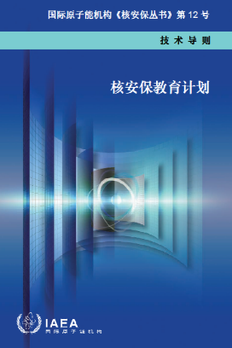
NSS 12: Educational Programme
in Nuclear Security

Nuclear Security Recommendations NSS 13
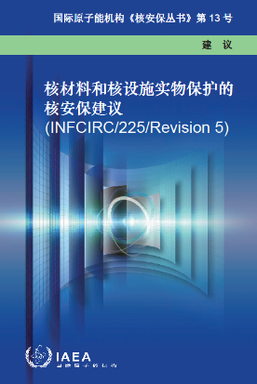
NSS 13: Nuclear Security Recommendations on Physical Protection
of Nuclear Material and Nuclear Facilities (INFCIRC/225/Rev. 5)

Guidance under NSS 13 ‒ Physical Protection
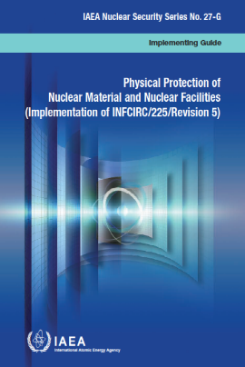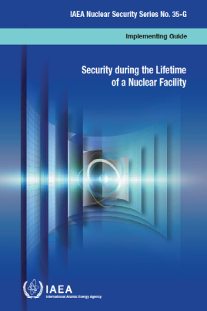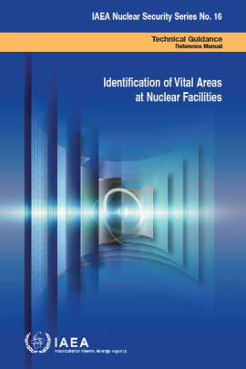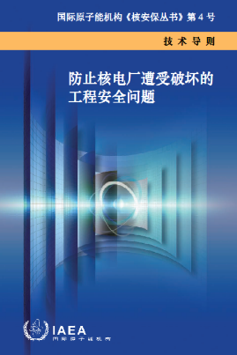
NSS 27-G: Physical Protection of NSS 35-G: Security during the NSS 16: Identification of NSS 4: Engineering Safety Aspects of the
Nuclear Material and Nuclear Facilities Lifetime of a Nuclear Facility Vital Areas at Nuclear Facilities Protection of Nuclear Power Plants
(Implementation of INFCIRC/225/Rev. 5) against Sabotage

Guidance under NSS 13 ‒ Material Accounting and Inventory
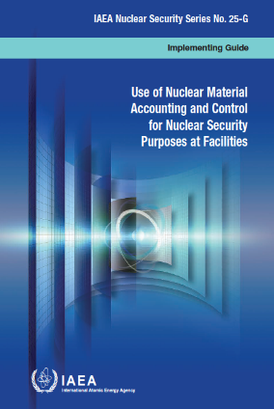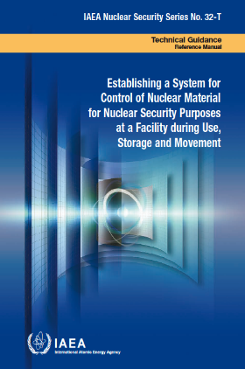
NSS 25-G: Use of Nuclear Material Accounting and Control NSS 32-T: Establishing a System for Control of Nuclear Material
for Nuclear Security Purposes at Facilities for Nuclear Security Purposes at a Facility during Use, Storage and Movement

Guidance under NSS 13 ‒ Contingency Planning
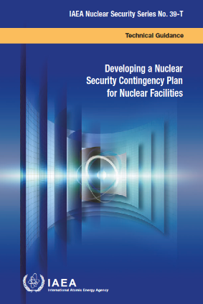
NSS 39-T: Developing a Nuclear Security
Contingency Plan for Nuclear Facilities

Guidance under NSS 13 ‒ Threat Assessment
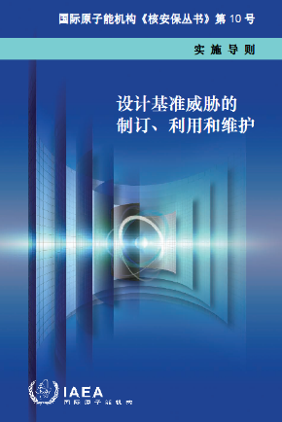
NSS 10: Development, Use and Maintenance
of the Design Basis Threat

Guidance under NSS 13 ‒ Transport
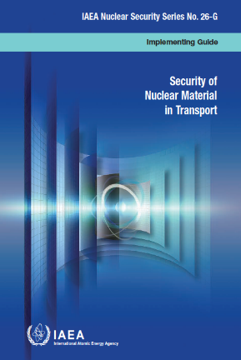
NSS 26-G: Security of Nuclear Material in Transport

Guidance under NSS 13 ‒ Computer Security
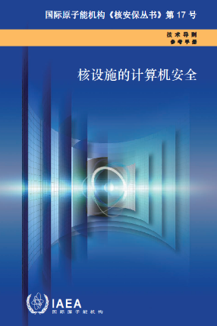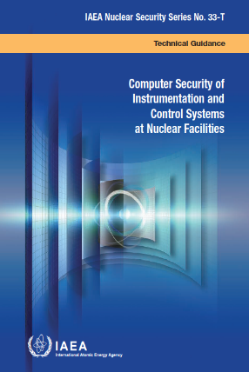
NSS 17: Computer Security at Nuclear Facilities NSS 33-T: Computer Security of Instrumentation and Control Systems
at Nuclear Facilities

Guidance under NSS 13 ‒ Security Culture
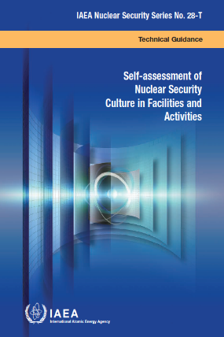
NSS 7: Nuclear Security Culture NSS 28-T: Self-Assessment of Nuclear Security Culture
in Facilities and Activities

Nuclear Security Recommendations NSS 14
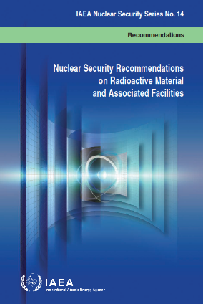
NSS 14: Nuclear Security Recommendations on
Radioactive Material and Associated Facilities

Guidance under NSS 14 ‒ Physical Protection
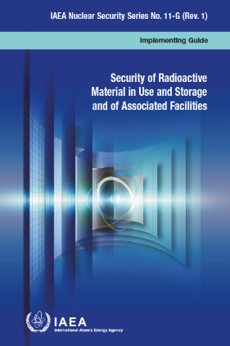
NSS 11 (Rev 1): Security of Radioactive Material
in Use and Storage and of Associated Facilities

Guidance under NSS 14 ‒ Threat Assessment
NSS 10: Development, Use and Maintenance
of the Design Basis Threat

Guidance under NSS 14 ‒ Transport
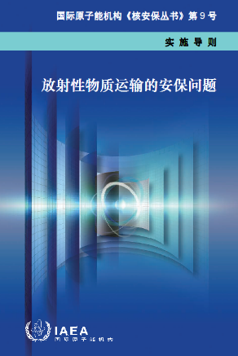
NSS 9: Security in the Transport of Radioactive Material

Guidance under NSS 14 ‒ Security Culture
NSS 7: Nuclear Security Culture NSS 28-T: Self-Assessment of Nuclear Security Culture
in Facilities and Activities

Nuclear Security Recommendations NSS 15
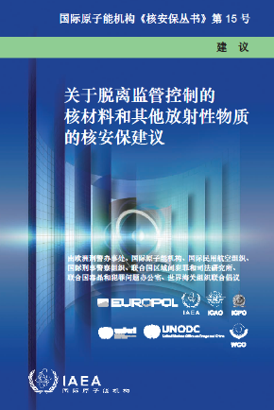
NSS 15: Nuclear Security Recommendations on
Nuclear and Other Radioactive Material out of Regulatory Control

Guidance under NSS 15 ‒ Prevention
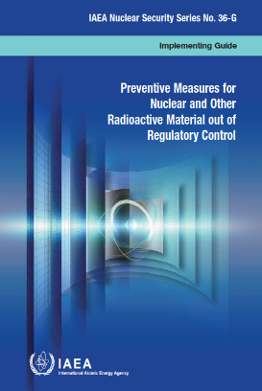
NSS 36-G: Preventive Measures for
Nuclear and Other Radioactive Material out of Regulatory Control

Guidance under NSS 15 ‒ Planning for Material out of Regulatory Control
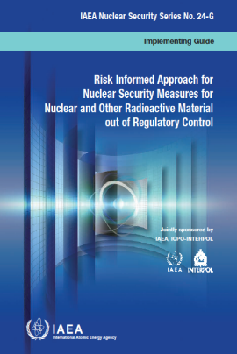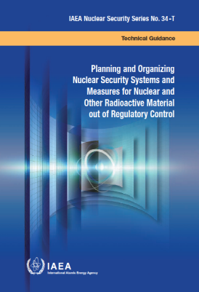
NSS 24-G: Risk Informed Approach for Nuclear Security Measures NSS 34-T: Planning and Organizing Nuclear Security Systems and Measures
for Nuclear and Other Radioactive Material out of Regulatory Control for Nuclear and Other Radioactive Material out of Regulatory Control

Guidance under NSS 15 ‒ Detection of Material out of Regulatory Control
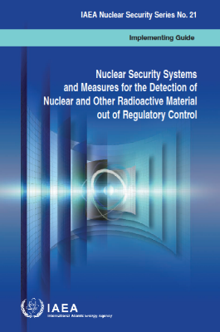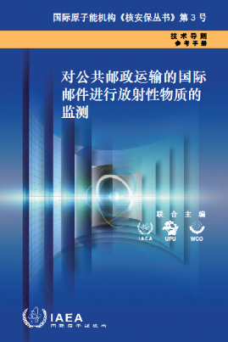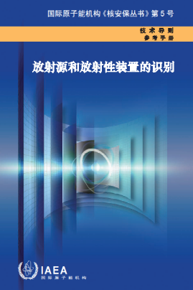
NSS 21: Nuclear Security Systems NSS 3: Monitoring for Radioactive Material NSS 5: Identification of
and Measures for the Detection of in International Mail Transported by Radioactive Sources and Devices
Nuclear and Other Radioactive Material Public Postal Operators Border Monitoring Equipment
out of Regulatory Control

Guidance under NSS 15 ‒ Response to Nuclear Security Events
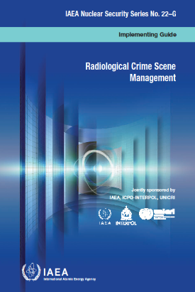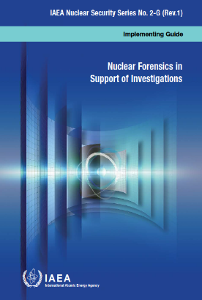
NSS 22-G: Radiological Crime Scene Management NSS 2-G (Rev. 1): Nuclear Forensics in Support of Investigations

Guidance under NSS 15 ‒ Major Public Events
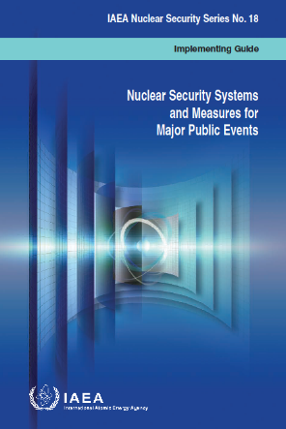
NSS 18: Nuclear Security Systems and Measures for Major Public Events

Guidance under NSS 15 ‒ General Guidance
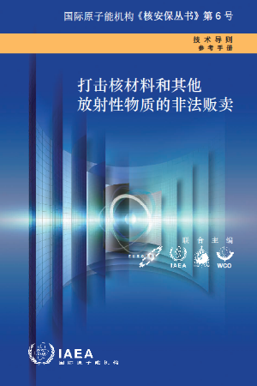
NSS 6: Combating Illicit Trafficking
in Nuclear and Other Radioactive Material

